Project Level 0: Web and Mobile Web Blood Bank
This project acts as an important role in saving life of human beings and which is also its main aim. The project Web and Mobile Web Blood Bank system is developed so that users can view the information about registered blood donors such as name, address, and other such personal information along with their details of blood group and other medical information of donor. The project also has a login page where in the user is required to register and only then can view the availability of blood and may also register to donate blood if he/she wishes to. This project requires internet access and thus there is a disadvantage of internet failure. Thus this application helps to select the right donor online instantly using medical details along with the blood group. The main aim of developing this application is to reduce the time to a great extent that is spent in searching for the right donor and the availability of blood required. Thus this application provides the required information in no time and also helps in quicker decision making.
Blood Types:
Although all blood is made of the same basic elements, not all blood is alike. In fact, there are eight different common blood types, which are determined by the presence or absence of certain antigens – substances that can trigger an immune response if they are foreign to the body. Since some antigens can trigger a patient's immune system to attack the transfused blood, safe blood transfusions depend on careful blood typing and cross-matching.
There are four major blood groups determined by the presence or absence of two antigens – A and B – on the surface of red blood cells:

Group A – has only the A antigen on red cells (and B antibody in the plasma)
Group B – has only the B antigen on red cells (and A antibody in the plasma)
Group AB – has both A and B antigens on red cells (but neither A nor B antibody in the plasma)
Group O – has neither A nor B antigens on red cells (but both A and B antibody are in the plasma)
There are very specific ways in which blood types must be matched for a safe transfusion. See the chart below:
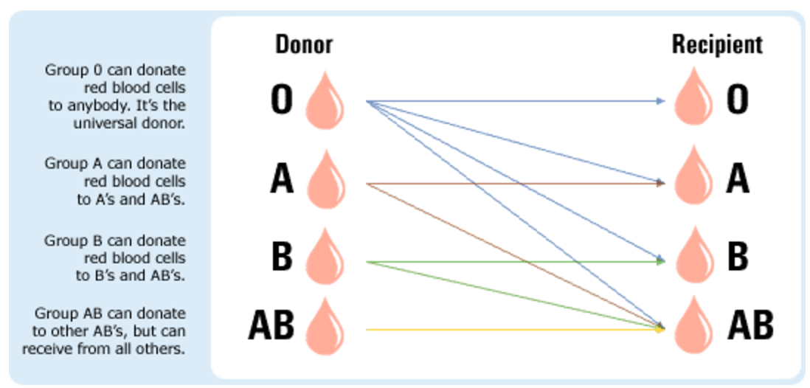
In addition to the A and B antigens, there is a third antigen called the Rh factor, which can be either present (+) or absent ( – ). In general, Rh negative blood is given to Rh-negative patients, and Rh positive blood or Rh negative blood may be given to Rh positive patients.

The universal red cell donor has Type O negative blood type.
The universal plasma donor has Type AB blood type.

Features:
- User login: This allows only the registered users to login in order to use this location tracking application.
- Donor details: This module helps the donor to insert all the necessary details that is personal information and medical information plus the blood group which together helps to select a donor.
- Procurer details: The web or mobile web user can view all the donor details and select the required donor on the basis of the donor’s information.
- Front End: The React Stack: React, Redux, React Router, RxJS, React Material Components
- Backend: Firebase
- Unit Tests: The App will not be considered complete unless extensive unit tests will accompany the software. (Read Chapter 16 of React Quickly). Please note if your app has a bug, a human may die.
Advantages:

This project has a login page, which allows only the registered user to login and thereby preventing unauthorized access.
This system can be used to view all the donor details and accordingly select the right donor.
The web or mobile user will be able make quick decision in selecting a donor.
Usage of this application will greatly reduce time in selecting the right donor.
Disadvantages:
- The user will not be able to insert or view details if the server goes down. Thus there is disadvantage of single point failure.

Applications:
- This application can be used by any common person.
- The application can prove very beneficial in to the clinics, hospitals as the requirement is very high in such places.
- The application must be viewable on both the desktop and/or mobile browser.

Blood Type Reading Material:
  - http://www.redcrossblood.org/learn-about-blood/blood-types
  - https://en.wikipedia.org/wiki/Blood_type
  - http://www.nhs.uk/conditions/Blood-groups/Pages/Introduction.aspx

Note for Python Django and Flask Developers (Python Developers can also participate):
You will implement this functionality in both Django and Flask on the server side i.e. you will develop two duplicate servers one in Django and one in Flask.
You will create a REST API’s for this functionality, which Mobile and Web apps will be able to call. You will define HTTP endpoints, which will have GET, POST, PUT and DELETE request methods, which accepts, and output JSON.
You will use PostgreSQL database on the backend.
You will not only manually test the REST API’s using Postman, but also write automated Unit tests that make use of an Http Client that hits all your end points and performs assertions on the JSON responses.
Unit Testing: http://www.drdobbs.com/testing/unit-testing-with-python/240165163
HTTP Client: https://docs.python.org/3.5/library/http.client.html
Book: https://www.safaribooksonline.com/library/view/building-restful-python/9781786462251/
Tutorial for Flask: https://www.cs.utexas.edu/~cannata/networking/Class%20Notes/07%20Designing%20a%20RESTful%20API%20with%20Python%20and%20Flask%20-%20miguelgrinberg.pdf

You will document the API using:
https://swaggerhub.com/

